Arithmetic
Monday 8th February

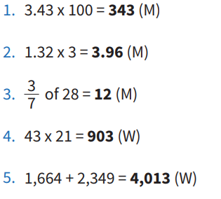

Support
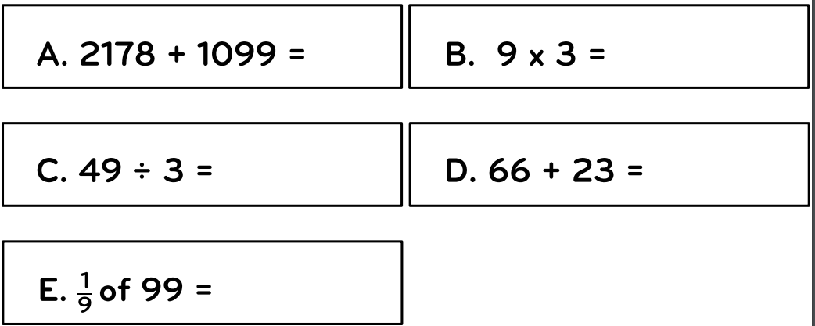
Use the bar model to help with question E
99

