Thursday 11th February
LO: I can identify a verb ‘to be’.

To explore 'being' verbs
In this lesson, you will be given a definition of 'being' verbs. First, you will identify the forms of the verb 'to be' in sentences. Then, you will look at plural and singular forms of the verb 'to be'. After that, you will look at past/present tense forms of the verb 'to be' and finally, you will complete a task where you need to choose the correct verb for each sentence.

https://classroom.thenational.academy/lessons/to-explore-being-verbs-6mr68r

Here are the different forms of the verbs ‘to be’.
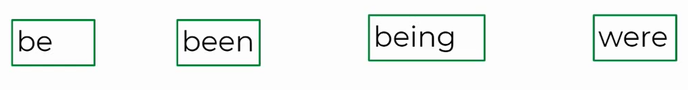
Tasks
- Underline the ‘being’ verbs in these sentences.
She is silly. I am hungry. They are young.

- Underline the ‘being’ verbs in the sentences.
He was happy. I was tired. They were brilliant at art.

- Write your own sentence using a ‘being’ verb and underline it when you are finished.

- Underline the verbs in each of these sentences.
He was happy. They were happy.

Present and Past Tense
- Underline the verbs in the sentences.

He is tired. He was tired.

- Underline the verb in these sentences.

They are tired. They were tired.

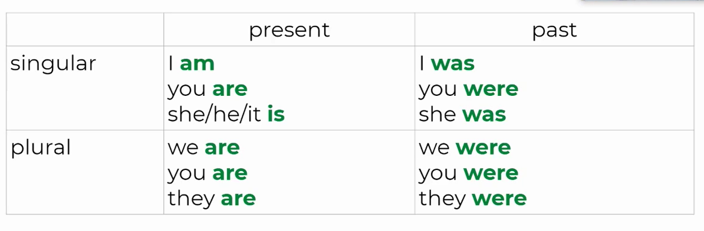

- Choose the appropriate verb for each sentence below.
are
is
am

I ________________ late for school.
They ____________ exhausted.
She ___________ is funny.

8. What tenses are the sentences above? How do you know?
The sentences are in the __________ tense because_________________

Challenge yourself. Write 2 sentences using forms of the verb ‘to be’. See if you can write them in the past tense!

