Science lesson Amber class 7th January 2020
Hello Amber Class,
I hope you had a good Christmas holiday and all of you and your families are safe and well.
We still have a few more lessons on our current science topic Forces and Magnets Last time you were busy finding magnetic objects, testing how strong magnets are, tested a range of different types of magnets and made a paper clip flow. Today I would like you to investigate the poles of a magnet.
Question:
- What do we mean by attract and repel?
- How are magnets related to the North Pole?

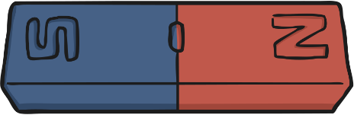
Look at this bar magnet. It has two different sections, which are often coloured red and blue. But what are these sections?

I would like you to watch this clip.
Magnets and their invisible force - KS2 Science - BBC Bitesize
While you are watching, can you listen for the answers to these questions? You can write them down.
- Which three metals are attracted to magnets?
- What happens when two magnets repel each other?
- What are the different parts of a magnet called?
- Which way will a compass always point?

What did you find out? (see the correct answers below)
- The three metals that are attracted to magnets are iron, cobalt and nickel.
- When two magnets repel each other, they push away from each other.
- The different parts of a magnet are called the poles. There is a north pole and a south pole.
- A compass always points north-south.
Now try to complete the following activity.
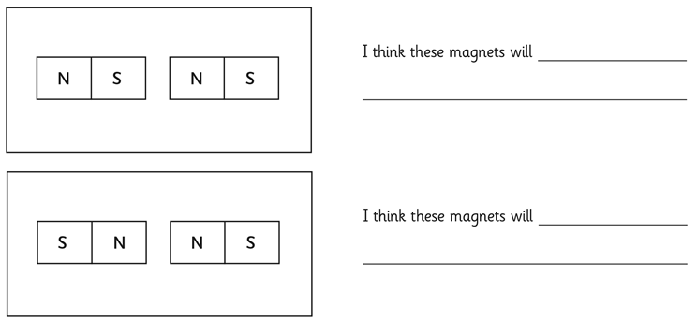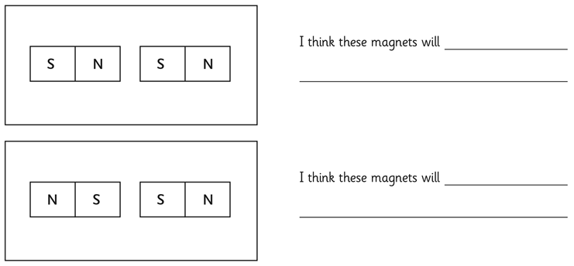

Answers:
The north pole of a magnet will always attract to the south pole of another magnet. If two north poles or two south poles are together, they will repel each other. When this happens, the magnets will move away from each other.

How are magnets related to the North Pole?
A compass is a tool for finding direction. A simple compass is a magnetic needle which can spin freely and always points north.
A compass works because Earth is a huge magnet. It points north because it lines up with Earth’s lines of magnetic force.
Earth’s magnetic poles are not the same as the geographic North and South poles (the top or bottom of a globe). The magnetic poles are nearby but not exactly at the same places. A compass always points to the magnetic North Pole, not the geographic North Pole, therefore, a compass user must adjust to find true north.

Further optional activity:
I am not sure if you have a bar magent at home. If yes, here are some instructions how to make a Magnetic Compass.

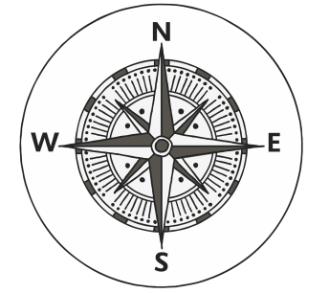
You will need: a bar magnet, a flat plastic lid, a plastic bowl, water and this compass template.

Instructions:
1. Cut out the compass template and stick it inside the plastic lid, so that it faces outwards.
2. Place the bar magnet inside the plastic lid on the compass template, making sure it is placed along the north-south line with the north pole of the magnet on the ‘north’ side of the line.
3. Half fill the plastic bowl with water. Float the plastic lid on the water.
4. The magnet will cause the plastic lid to rotate on the water until the north pole of the magnet points north.
5. Keep your compass away from computers and other devices that contain magnets, as it could disrupt their systems.
6. Test your compass by slowly turning the bowl around. The magnet should continue to point north even if the bowl moves.

Good luck!

Many thanks,
Mrs Kite

