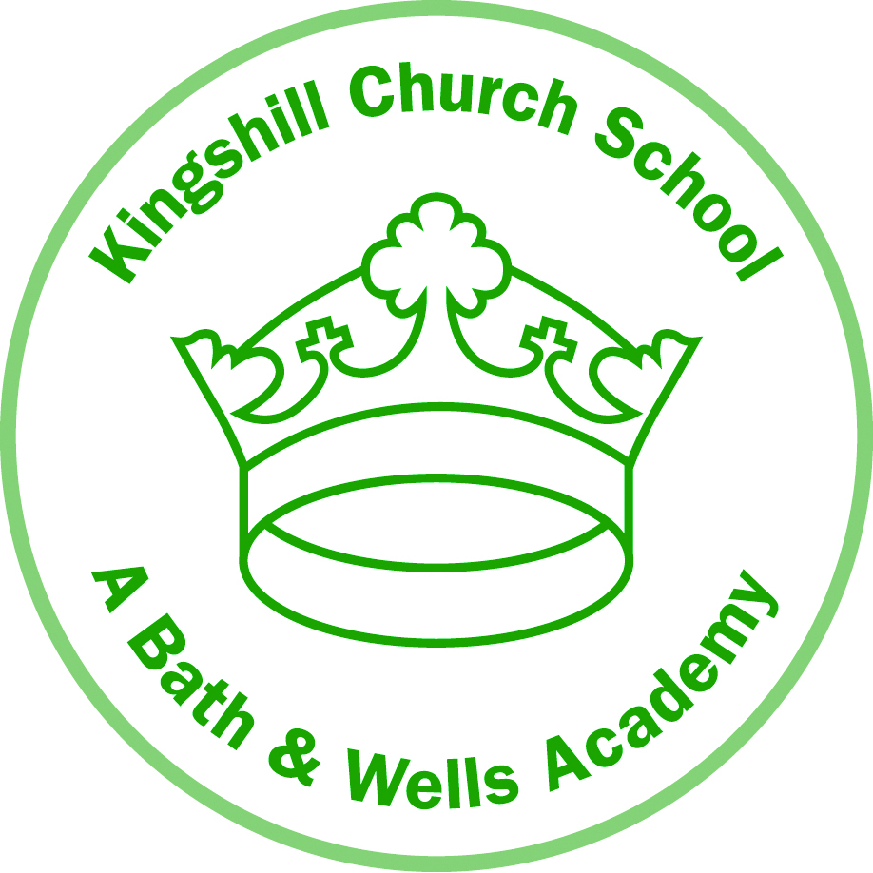

Pound Lane

Nailsea
North Somerset
BS48 2NP

Telephone: 01275 852720
Headteacher:
Mrs Jan Thomson

4 June 2020
Dear Parents and Carers,

In my letter to you last week, I confirmed I would communicate our decision about the reopening of all Bath and Wells Multi Academy Trust schools from Monday 8 June by the end of the school day today.

I’m pleased to let you know that we have received confirmation from the Local Authority following analysis of the North Somerset data, carried out by Public Health England, that ‘there is no increased risk of Covid-19 in the local population connected to the outbreak at Weston General Hospital.’

The Bath and Wells Multi Academy Trust in consultation with Headteachers can confirm that the opening date for schools in our Trust will be Monday 8 June 2020.

The planned arrangement for children returning in Reception, Year 1 and Year 6 will proceed in line with the individual school arrangements already communicated to you.

Provision in each school for the children of key workers and vulnerable groups will continue. The home learning support schools are providing will also continue for those children not attending school.

Headteachers and school staff are very much looking forward to welcoming pupils back to school.

I would like to thank you for your patience and understanding. I apologise for the significant inconvenience this delay may have caused you.

Please be assured that we will continue to monitor the situation very closely, listen to your feedback and respond accordingly.

My very best wishes to you and your family.

Philip Bowditch

