
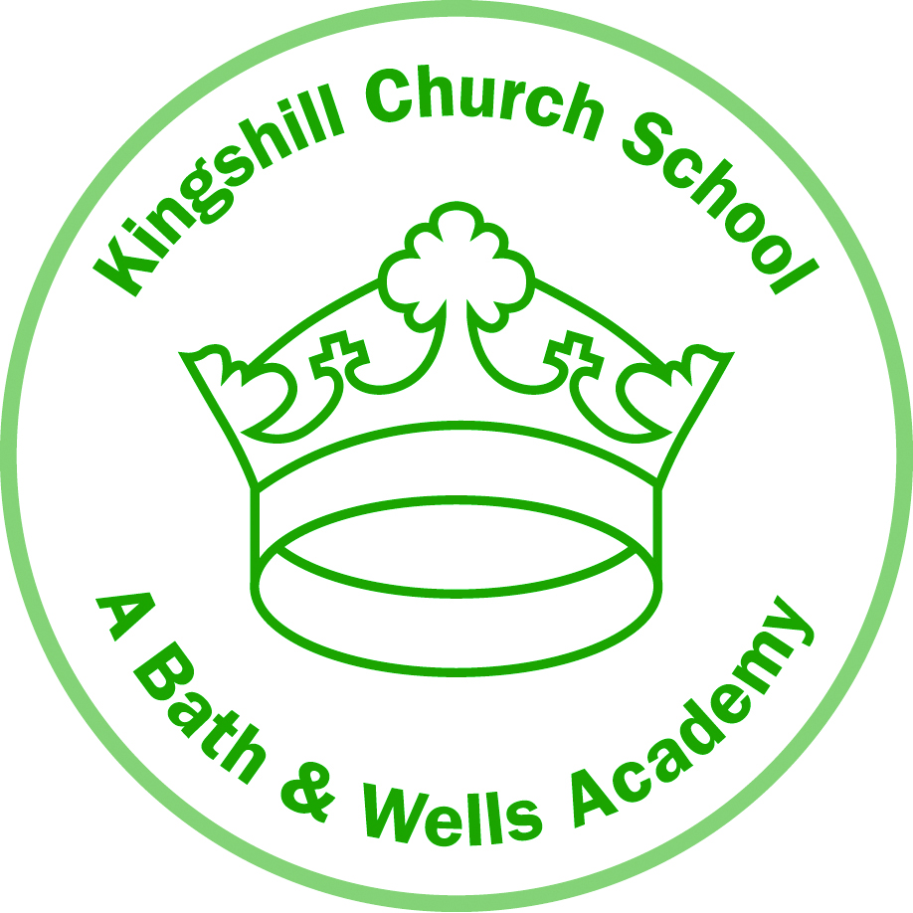

Pound Lane

Nailsea
North Somerset
BS48 2NP

Telephone: 01275 852720

Headteacher:
Mrs Jan Thomson

10 January 2020

Dear Parents/Carers

On Thursday 13 February Year 6 children have the opportunity to spend the morning at the Lifeskills Centre in Bristol. Amongst other activities, they will be learning about first aid skills, road safety and how to respond in an emergency situation.

We will be leaving school at 9 15 am and returning by 12 30 pm therefore the children will require a packed lunch to eat when they return to school. If you want to order a packed lunch from the kitchen at a cost of £2.10 please indicate this in the appropriate box on ParentPay. If your child is entitled to free school meals then the cost will be met by the school however please still complete the box.

On this occasion we are very fortunate to be able to offer the children this opportunity free of charge. This is because the KFA have kindly agreed to cover the full cost to which we are very grateful.

Please log in to ParentPay to give your consent by Friday 24 January 2020 at the latest.

Yours sincerely

Jan Thomson
Headteacher

Consent can be withdrawn at any time by contacting the school office in writing.

All data is collected in line with our Privacy Notice and Data Protection Policy which can be found at www.kingshill.bwmat.org.

