

**Forest School**

Dear Parents/Carers

Forest School is continuing again this year. This year your child will be taking part in the Forest School programme.

Forest School sessions will be mainly on **Friday afternoons**.

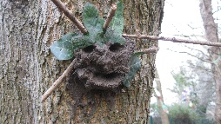Forest School is an opportunity for children to spend time outside exploring and learning from practical hands on activities and play. It is a time where they have space to follow their own interests and develop learning behaviours such as resilience, confidence and risk taking. The activities will be led by the interests of the children but possible activities include:

* 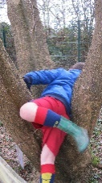Bug hunting
* Natural crafts
* 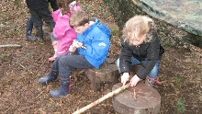Shelter building and knot tying
* Building a campfire and cooking
* Using tools

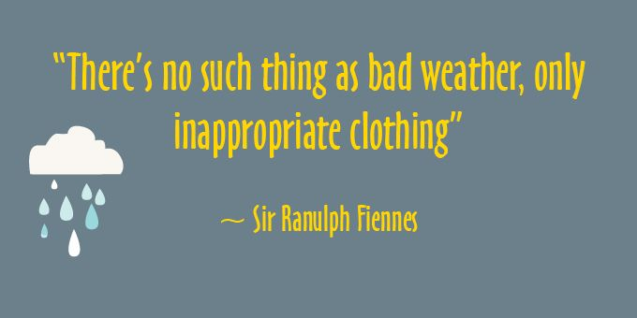We have policies in place and risk assessments to ensure that the risks in these activities have been reduced to an acceptable level.

An important part of Forest School is that children will experience the outdoors in **all** weathers. The only exception will be in thunderstorms or very high winds. To help achieve this, we have waterproof trousers and wellies in school for the children to wear. We ask you to supply a waterproof coat.

**Everyone** needs to be safe whilst participating in Forest School so if any pupil behaves in a way that is inappropriate or unsafe the school behaviour policy will be applied and Forest School sessions may be missed as a result.

Please give your consent on ParentPay so that your child can take part in Forest School. If you have any questions, please feel free to contact me.

Yours sincerely

Mrs J Davies

Forest School Leader